8.1-1)
The algorithm in the old version assumes the first element to tbe the pivot. Also j starts from the end of the array rather than from the beginning.

13 | 19 | 9 | 5 | 12 | 8 | 7 | 4 | 11 | 2 | 6 | 21
i=-1 j=12 x=13

13 | 19 | 9 | 5 | 12 | 8 | 7 | 4 | 11 | 2 | 6 | 21
i=0 j=10

6 | 19 | 9 | 5 | 12 | 8 | 7 | 4 | 11 | 2 | 13 | 21
i=1 j=9

6 | 2 | 9 | 5 | 12 | 8 | 7 | 4 | 11 | 19 | 13 | 21
j= 8 i=9

since i>=j, return 8

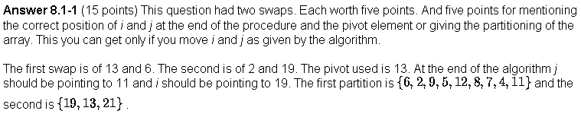

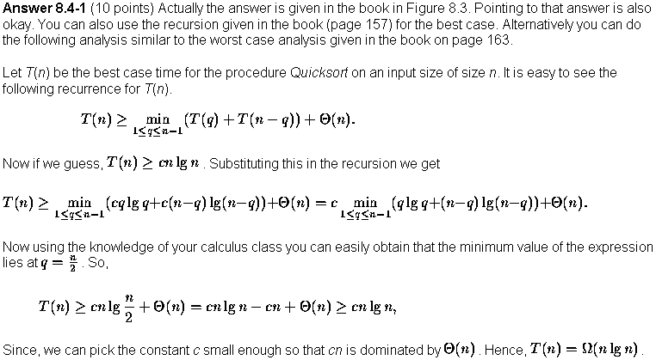

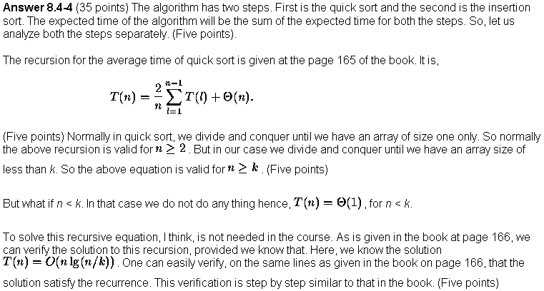
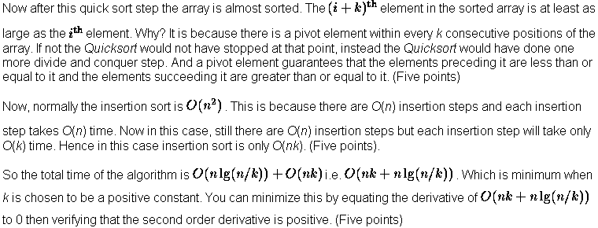

8-3)
a)
The algorithm produces smaller sublists in each of the recursive calls. It terminates on problems set size of two, in which case it does sort correctly. So it will terminate eventually.
It sorts the first two-third elements, then last two-thirds, the again the first two thirds. So lets consider sorting a three element array: The first two will be sorted by call to StoogeSort, so bigger of the two will go to index 2. Again the last two-thirds is sorted using StoogeSort, this takes the maximum of three to the index 3.
Now another call to Stooge Sort on the first two-thirds takes the smallest of the three to index 1. So Stooge Sort is also working correctly on set size of 3.
Going in this way, we can say that for any set size, it calls StoogeSort on the first two-thirds, which we assume works properly, putting the bigger one-third elements in the high-end of this two-third. Then we call StoogeSort on the last two-thirds, this will take the bigger of this two-thirds (so the biggest one third of the original set) to the high-end. The next call of StoogeSort on the first two-thirds will resort the first two-third, taking any small values from the high end of the original set to the low one-thirds part. Thus the total array is sorted correctly.

b) T(n) = 3T(2n/3) + Θ(1)
Solving, we get T(n) = Θ(n ^{log 3/2 3} )

- The worst case running time of the other sorts is Θ (n² ). But StoogeSort’s worst case
running time is greater than this. So they do not deserve tenure.

